Some observations related to the 4CT
Van den Driessche Willy

Contents
1 Maximal planar graphs 2
2 Three rules 2
3 The transformations are key 3
3.1 Rule 1 3
3.2 Rule 2 3
3.2.1 The idea 3
3.2.2 They do go down 4
3.2.3 They go down in chains 4
3.2.4 Visualizing the transitions 6
3.3 Rule 3 8
3.3.1 The idea : same as rule2 8
3.3.2 Second idea : other rule, other law 9
4 Observation about maximum x for count of vertex 10
5 Observation about set of colofour transitions for a given vertex count. 10
5.1 Update 20151023 12
5.2 “Pure” rule 2 transitions 13
6 Observation about maximum y for count of vertex 14
6.1 Update 20151022 14
6.2 Jakobsthal graphs 16
6.3 Jakobsthal graphs wheels 18
6.4 The fish 18
7 Observation about transitions at colofive 19
8 Observations that border numerology 20
8.1 Colofive 20
8.1.1 Rule1 20
8.1.2 Rule 2 20
8.1.3 Rule 3 21
9 More Jacobsthal graphs 22
9.1 Jacobsthal graphs are colour champions. 22
10 Implementation 24
10.1 Optimization : partition key 28
11 References : 29

In this document I describe some observations I made when tackling the 4CT.
Some of them I have not encountered in any previous work.
A nice fact (for me) is that we can generate all maximal planar graphs with just 3 rules. The new observation is mainly about the transitions caused by these rules : Rule 1 keeps the number of 4-colourings constant, rule 2 at most halves it and rule 3 at most divides it by 4. If we can prove these 3 facts (which I currently can’t) then we can prove the 4CT.
My observations are presented as the chaotic journey they were/are and not as a finsihed paper. It is possible that some “thought transitions” still need clarifications.

Maximal planar graphs
I approached the 4CT like many other people have tackled it. I came to the conclusion that it was sufficient to concentrate on maximal planar graphs (MPG); graphs that lose their planarity if you add another edge to them.

Three rules
Another thing I wanted to do is approach these MPG in a generative way. We start with MPGS of order n and proceed to MPGs of order n+1. The idea was to “order” them by number of vertices so that we could apply some kind of induction rule on them.
It is sufficient to start with K4. From there on, we generate MPGs. To get from an MPG with n vertices to an MPG with n+1 vertices, I found 3 rules. ( I found these rules later in at least 3 papers giving me confidence that this was correct.)
Rule1 is simple : Embed the planar graph. Embed a new vertex in the middle of any face. Connect the vertex to the 3 boundary vertices of the previous face. This can be visualized as follows : 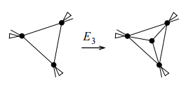.
Rule2 is equally simple : Add a new vertex in the middle of any edge. Connect the new vertex to the vertices on the faces. 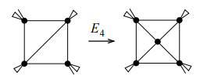
Rule3 came much later (after I saw that my calculations had less solutions than standard implementations). It involves a pentagon and can be visualized as follows :
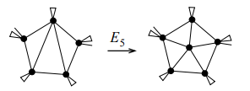

These 3 rules have been used by others. The Plantri program uses them to generate MPGs in the blink of an eye.

I rendered these MPGs, hoping to see some patterns in them.
I quickly put this aside because I realized a lot of people had already looked at these graphs.

The transformations are key
Then I realized that I had to see the transformations as the key of my approach.
Instead of looking at an MPG, I decided to look at the rules and to see what invariants they carried with them.
The “hoped for” invariant would of course be that each rule moves from a 4-colourable MPG to another 4-colourable MPG. If we could prove that that we would have a basis for a proof by induction. To do this, I had a look at each rule seperately.

Rule 1
It was clear that Rule1 did not change the way you could colour the graph with 4 colours. If the original graph could be coloured with 4 colours in n ways, then after applying rule 1 to it, we would have a new graph with one more vertex but which could also be coloured in the same n ways. The colour of the new face center is completely determined by the original corners of the triangular face.

Rule 2

The idea
The goal was to have the same approach for rule 2. If we could start with a 4-colourable graph with n vertices that could be coloured in k ways, then we hoped that applying rule 2 would always lead us to a graph with n+1 vertices that could be 4-coloured in also at least k ways.
Luckily for me, Mathematica has a built-in ChromaticPolynomial method. If we feed 4 into that polynomial, we can see the number of possible ways to colour the graph with 4 colours. (I actually programmed this myself too and reached the same results but an order of magnitude slower ;-) )

They do go down
Unfortunately, I quickly found that this doesn’t hold. There are graphs with n vertices for which the number of ways to colour them with 4 colours goes down after applying rule 2. We illustrate this with an example:
The following picture shows a graph to which rule 2 is being applied :
In this graph, vertex 8 has been added on an edge (previously) between vertex 1 and 5. The graph without node 8 can be 4-coloured in 96 ways, while this graph can be 4-coloured in only 72 ways. So while there is an additional vertex, the 3 additional edges make it so that the number drops.
Ok. That was a disappointment.

They go down in chains
But I thought. Ok, the number goes down, but it only goes down once and afterwards it goes back up again. Unfortunately, I found some chains of graphs that have successive lower numbers. This means that if we move from n to n+1 to n+k vertices, the number of ways to colour them goes down on each step. Let’s again illustrate this with an example:
The graphs in the following pictures have succesively more vertices. But they go from 336 possibilities down to 144. In each step we add a node (you can see which because the vertex numbers increase and the new node has the highest vertex number).
This experiment gave the hint that these chains could be as long as possible if we wanted.

Visualizing the transitions
My first attempt was to visualize the “color transitions” for rule2 through a graph. If the colors drop from 48 to 24 then I would add vertices 48 and 24 and connect them through an edge. I would then ask Mathematica to draw that graph to get an idea of these transitions. This gave the following solution :
The above graph contains the number of 4 colourings divided by 24. This gives easier numbers. Let’s call this number the colofour of a graph : the number of ways to color that graph with 4 colors, divided by 24.
This was suboptimal but it suggested something. Apparently colofour 2 is only reached from colofour 3; 3 is only reached through 4 and 5. Hm.
Then, by accident actually, I plotted these “edges” as points in a normal carthesian graph. This produced the following surprising graph :
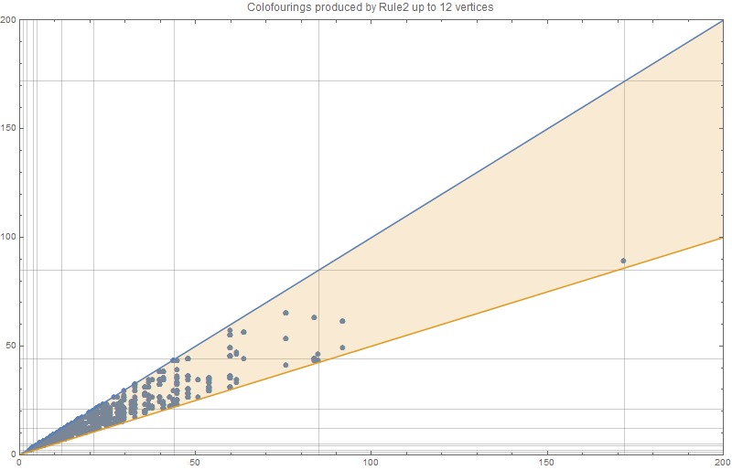
Let’s be very clear about what is in this graph. A dot (x,y) is in the graph if there is a graph g with n vertices and colofour x is transformed into a graph h with n+1 vertices an colofour y through a rule2 transition. In addition we ask that y<=x. There are more transitions than the one shown. But we only show the when the colofour drops (or stays the same). (There is a graph with all transitions a bit further in the document)
When I saw this graph I was completely surprised. If we zoom in on the x<=50, we see this:
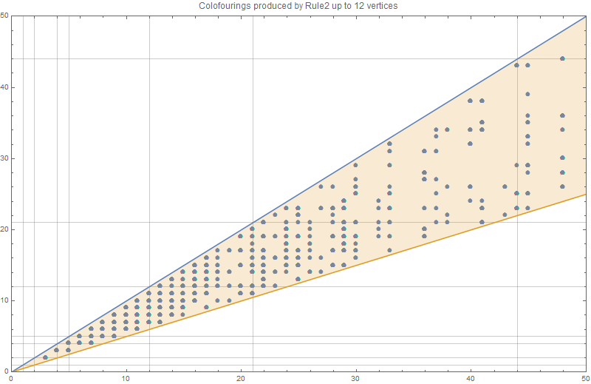
We notice that most (x,y) values are there. However, we also notice that apparently a rule 2 will never go lower than half of the previous colofour. Actually, it won’t even drop to half the previous. It will always be one more. Ex 5 will drop to at most 3 and 6 to at most 4.
Now this is a property about rule 2 that I have found nowhere. If we could prove this property then we would have solved 66% of the 4CT (counting rule 1 as the easiest 33%)
- A rule 2 transition from F to G will never bring the colofour down to less than or equal half of the original colofour.

Rule 3

The idea : same as rule2
With the image of rule2, I quickly wrote a program to collect rule3 transitions. I expected rule 3 to behave exactly like rule 2. Unfortunately, I got the following picture:
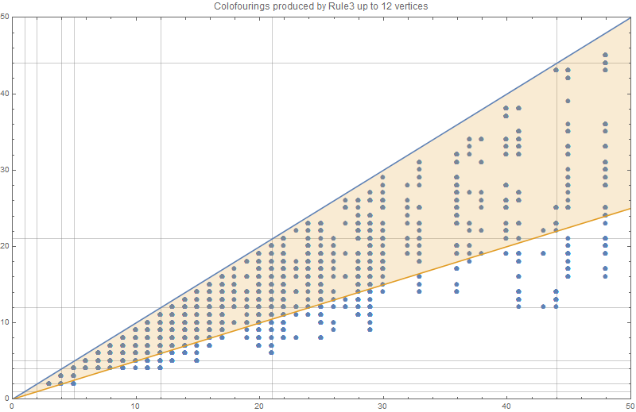
You can see that the blue dots below the orange line don’t obey the rule2 conjecture. The lowest such colofour transition happens at 5,2.
The graphs that go with this transition are shown below (vertex 9 will be added in the pentagon 7,8,4,3,1)
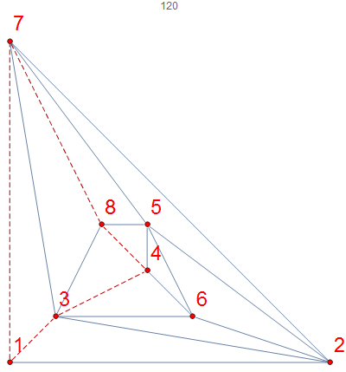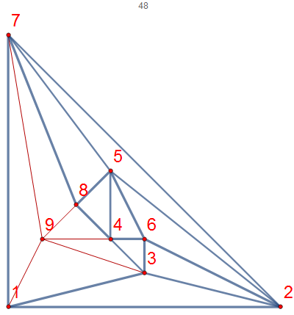
The original graph on the left has colofour 5 while th eone on the right with vertex 9 added has colofour 2.

Second idea : other rule, other law
But then I realized that rule 3 and rule2 are quite different. So there is no reason for rule3 transitions to obey exactly the same law as rule2. This leads me to the idea that the law for rule3 is similar (but not the same) to the law of rule 2. In a picture this gives us:
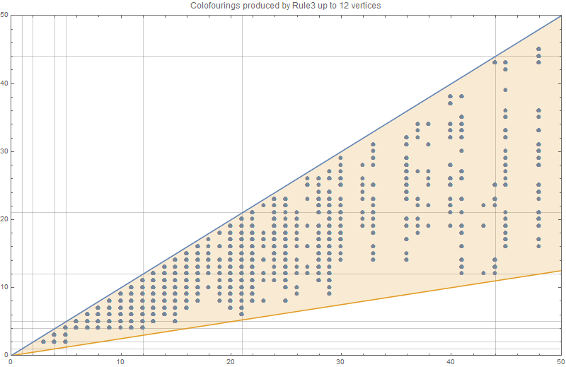
I saw that, just like rule2 there is a "line" below which there are no colour transitions. While the “forbidden” line for rule 2 lies at y=x/2, the line for rule 3 seems to lie at y=x/4.
- A rule 3 transition from F to G will never bring the colofour down to less than or equal to one fourth of the original colofour.
Again, If we would be able to prove this, we would have proven another 33% of the 4CT.
From the picture of rule3 the 1/4th rule is not all that obvious. With the limited data this law looks ok, but a more elaborate calculation this law might quickly break down.

Observation about maximum x for count of vertex
When we calculate the x,y for the colofour transition graph, we do so for increasing vertex counts. The reason is quite obviously that up until now I need a generation with n vertices before I can calculate a generation with n+1 vertices. (I could use Plantri to fast forward to m nodes but I would still need to calculate the transitions to m+1 nodes)
I noticed that for vertex count n, there was huge gap between the maximum x and the other “x’s”. So I got interested in knowing the maximum x for a certain vertex count.
This got me the table { 1, 4, 5, 12, 21, 44, 85, 172, 341, 684, 1365, … } Thanks to OEIS I found that these are the so-called A155944 sequence of “Jacobsthal numbers A001045, every second term incremented by 1.”. I have no idea how to explain this but it leads to another conjecture.
- The colofour transition (x,y) with maximum x for a given vertex count is related to the Jacobsthal numbers.

Proving this conjecture might provide a “horizontal” (because it’s about x) upper bound that might be useful for “framing” problems for the other conjectures.

Observation about set of colofour transitions for a given vertex count.
I made another observation regarding colofour transitions. Suppose KF(n) is the set of all (x,y) so that (x,y) is a colofour transition that happens between a graph with n vertices to a graph with n+1 vertices by some of the 3 rules.
To my surprise I noticed that KF(n) is always a proper subset of KF(n+1).
- The colofour transitions for vertex counts n are a proper subset of the colofour transitions of vertex counts n+1.
For this conjecture I have the feeling that there is some obvious observation that I am missing. It has the flavor of being trivial. Yet I don’t see the reason now.
Here are some sets related to rule 2 to make this observation more clear: (In row n+1 we color the items from row n to show that they indeed occur – we underline drops)
Vertex count | Unique colofour transitions for rule 2 (dropping and non-dropping)
7 | {1,1},{1,5},{4,5}
8 | {1, 1}, {1, 4}, {1, 5}, {1, 12}, {4, 3}, {4, 4}, {4, 5}, {5, 3}, {5, 12}
9 | {1,1},{1,4},{1,5},{1,12},{4,3},{4,4},{4,5},{4,9},{4,16},{5,3},{5,5},{5,6},{5,9},{5,12}
10 | {1,1},{1,4},{1,5},{1,12},{1,21},{3,2},{3,6},{3,9},{4,3},{4,4},{4,5},{4,9},{4,11},{4,16},  {4,20},{5,3},{5,5},{5,6},{5,7},{5,9},{5,12},{5,20},{12,7},{12,9},{12,11},{12,12},{12,21}
11 | {1, 1}, {1, 4}, {1, 5}, {1, 12}, {1, 21}, {1, 44}, {2, 5}, {2, 6}, {2, 8}, {3, 2}, {3, 3}, {3, 5}, {3, 6}, {3, 9}, {3, 12}, {3, 13}, {3, 14}, {3, 22}, {4, 3}, {4, 4}, {4, 5}, {4, 9}, {4, 11}, {4, 16}, {4, 20}, {4, 25}, {5, 3}, {5, 5}, {5, 6}, {5, 7}, {5, 9}, {5, 12}, {5, 14}, {5, 20}, {5, 25}, {5, 28}, {5, 41}, {6, 5}, {6, 6}, {6, 7}, {6, 13}, {6, 14}, {9, 5}, {9, 7}, {9, 8}, {9, 9}, {9, 10}, {9, 11}, {9, 14}, {9, 22}, {9, 28}, {9, 29}, {12, 7}, {12, 9}, {12, 11}, {12, 12}, {12, 13}, {12, 21}, {12, 41}, {16, 12}, {16, 14}, {16, 16}, {16, 20}, {21, 11}, {21, 14}, {21, 21}, {21, 25}, {21, 44}
12 | {1,1},{1,4},{1,5},{1,12},{1,21},{1,44},{1,85},{2,2},{2,5},{2,6},{2,8},{2,9},{2,16},{2,26},{3,2},{3,3},{3,5},{3,6},{3,9},{3,12},{3,13},{3,14},{3,15},{3,22},{3,29},{3,45},{3,54},{4,3},{4,4},{4,5},{4,9},{4,11},{4,16},{4,20},{4,25},{4,48},{5,3},{5,4},{5,5},{5,6},{5,7},{5,8},{5,9},{5,10},{5,12},{5,14},{5,16},{5,17},{5,20},{5,25},{5,28},{5,41},{5,60},{6,4},{6,5},{6,6},{6,7},{6,8},{6,10},{6,11},{6,13},{6,14},{6,16},{6,17},{6,19},{6,21},{7,4},{7,6},{7,7},{7,8},{7,11},{7,13},{7,14},{7,15},{7,16},{7,17},{7,22},{7,29},{8,7},{8,8},{8,10},{9,5},{9,7},{9,8},{9,9},{9,10},{9,11},{9,14},{9,22},{9,23},{9,27},{9,28},{9,29},{9,36},{11,6},{11,10},{11,11},{11,14},{11,17},{11,22},{11,25},{11,41},{11,45},{11,54},{12,7},{12,9},{12,11},{12,12},{12,13},{12,21},{12,41},{12,48},{12,60},{13,7},{13,9},{13,11},{13,13},{13,16},{13,17},{13,22},{14,9},{14,10},{14,11},{14,29},{14,40},{16,10},{16,12},{16,14},{16,16},{16,20},{16,22},{16,36},{20,11},{20,12},{20,15},{20,17},{20,20},{20,24},{20,25},{20,29},{20,36},{20,48},{21,11},{21,14},{21,21},{21,25},{21,44},{28,17},{28,29},{28,41},{44,25},{44,85}
13 | Are currently calculating…

A similar table holds for colofour due to rule 3
Vertex count | Unique colofour transitions for rule 3 (dropping and non-dropping)
8 | {{1,1},{1,4},{1,5},{4,3},{4,4},{4,5},{5,5}}
9 | {{1,1},{1,3},{1,4},{1,5},{4,3},{4,4},{4,5},{5,2},{5,3},{5,5},{5,6},{5,9},{5,12}}
10 | {{1,1},{1,3},{1,4},{1,5},{1,6},{1,9},{1,12},{3,2},{3,3},{3,6},{3,9},{4,2},{4,3},{4,4},{4,5},{4,6},{4,9},{5,2},{5,3},{5,5},{5,6},{5,9},{5,12},{5,13},{12,6},{12,12}}
11 | {{1,1},{1,3},{1,4},{1,5},{1,6},{1,7},{1,9},{1,11},{1,12},{1,21},{2,2},{2,5},{2,6},{2,8},{3,2},{3,3},{3,4},{3,5},{3,6},{3,8},{3,9},{3,11},{3,13},{3,14},{4,2},{4,3},{4,4},{4,5},{4,6},{4,7},{4,9},{4,10},{4,12},{4,13},{4,14},{4,16},{4,20},{5,2},{5,3},{5,5},{5,6},{5,7},{5,9},{5,11},{5,12},{5,13},{5,20},{5,25},{6,5},{6,6},{6,7},{6,8},{6,13},{6,14},{9,5},{9,6},{9,7},{9,9},{9,11},{9,13},{12,5},{12,6},{12,7},{12,9},{12,11},{12,12},{12,21},{16,13},{16,16},{21,7},{21,21}}
12 | {{1,1},{1,3},{1,4},{1,5},{1,6},{1,7},{1,9},{1,11},{1,12},{1,21},{1,25},{1,44},{2,2},{2,5},{2,6},{2,7},{2,8},{2,9},{2,10},{2,16},{3,2},{3,3},{3,4},{3,5},{3,6},{3,7},{3,8},{3,9},{3,10},{3,11},{3,12},{3,13},{3,14},{3,15},{3,16},{3,17},{3,21},{3,29},{3,33},{4,2},{4,3},{4,4},{4,5},{4,6},{4,7},{4,9},{4,10},{4,11},{4,12},{4,13},{4,14},{4,16},{4,20},{4,22},{4,36},{5,2},{5,3},{5,4},{5,5},{5,6},{5,7},{5,8},{5,9},{5,10},{5,11},{5,12},{5,13},{5,15},{5,16},{5,17},{5,20},{5,22},{5,23},{5,25},{5,28},{5,29},{6,4},{6,5},{6,6},{6,7},{6,8},{6,9},{6,10},{6,11},{6,13},{6,14},{6,16},{7,4},{7,6},{7,7},{7,8},{7,10},{7,13},{7,14},{7,22},{7,29},{8,7},{8,8},{8,10},{9,4},{9,5},{9,6},{9,7},{9,8},{9,9},{9,10},{9,11},{9,13},{9,14},{9,15},{9,16},{9,17},{9,19},{9,22},{9,28},{9,29},{9,33},{11,4},{11,6},{11,7},{11,10},{11,11},{11,13},{11,14},{11,17},{11,22},{11,25},{11,26},{11,41},{11,45},{11,54},{12,4},{12,5},{12,6},{12,7},{12,8},{12,9},{12,11},{12,12},{12,14},{12,21},{12,22},{12,30},{12,48},{12,60},{13,8},{13,9},{13,10},{13,11},{13,13},{13,16},{13,17},{13,22},{14,7},{14,8},{14,9},{14,10},{14,11},{14,13},{14,14},{14,16},{16,8},{16,9},{16,11},{16,12},{16,13},{16,14},{16,16},{16,20},{20,7},{20,8},{20,9},{20,11},{20,12},{20,13},{20,15},{20,16},{20,20},{20,22},{20,24},{20,25},{20,30},{20,36},{20,48},{21,6},{21,7},{21,11},{21,14},{21,21},{21,25},{21,44},{28,16},{28,22},{28,28},{44,14},{44,44}}
13 | Are currently calculating…

Update 20151023
I took me quite some thought to figure out the “proper subset” thing. But I found the reason.
I looked at some colofour transition for rule2, say a->b. This means that we are looking at graphs F with x vertices and colofour a that move to some other graph G with x+1 vertices and colofour b.
Now we compute these starting graphs F for various vertex counts x.
Let’s do this for drops a=120 to b=72. For x=11 we find a lot of colofour transitions. If we take an arbitary graph with 11 nodes, we could get this :
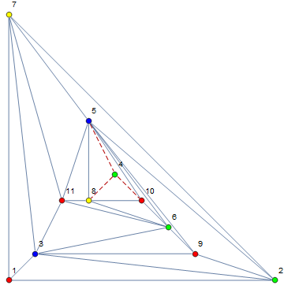
What we see is that this graph happens to contain a special substructure around vertex 4. In fact, vertex 4 could have been added by a rule1 on the face between vertices 5,8 and 10. Since this graph has a rule 2 transition that drops to colofour b=72 (actually rule2 could be applied on any of the edges 2<->5 or 5<_>7 or 3<->9 or 3<->6 or 3<->11).
The key thing is that deleting vertex 4 will not change the colofour. In other words, there exists a graph with fewer vertices that has colofour transitions that also occur in this graph instance.
If we turn this around then we see that any colofour transition a->b for F->G can yield an infinite number of other a->b transitions by applying rule1 to F to yield a set of F’ graphs. Since we can do the same on any of these F’ graphs, we have a way to convert any x->x+1 colofour transition into a x+n->x+n+1 transition.
This explains why colofours x->x+1 are always a proper subset of a x+n->x+n+1 transitions.

In addition, the same reasoning explains the subset conjecture for rule 3 colofour transitions.

“Pure” rule 2 transitions
We found out that some colofour transitions a->b for vertex count x->x+1 are actually nothing more than colofour transitions for some vertex count x’ which is smaller than x.
Therefore I thought it would be interesting to have a look at graphs that have a dropping colofour transition and that cannot be “reduced” using an “inverse” rule 1. If I do this for all graphs I had calculated, I get the following table:
- The first column is the number of vertices
- Column 2 contains the number of reducible graphs, i.e. graphs that contain a rule 1 reduction.
- Column 3 contains graphs that do not contain a rule 1 reduction.
- Column 4 is a “check”. Column2 and Column3 are mutually exclusive but together they should yield all MPGs with n vertices. The column in this document is actually computed from the two other columns and yields the expected value.
- Column 5 starts from the graphs in column 3 and sees which of these yield a drop in any of future generation the graphs obtained using a rule2 transition.
Number of vertices | Number reducible graphs | Number of non-reducible graphs | Sum | Number of non-reducible graphs with colofour drop
Count 4 | 1 | 0 | 1 | 0
Count 5 | 1 | 0 | 1 | 0
Count 6 | 1 | 1 | 2 | 0
Count 7 | 4 | 1 | 5 | 1
Count 8 | 12 | 2 | 14 | 2
Count 9 | 45 | 5 | 50 | 4
Count 10 | 221 | 12 | 233 | 12
Count 11 | 1215 | 34 | 1249 | 32
Count 12 | 7465 | 130 | 7595 | 122
Count 13 | 49041 | 525 | 49566

The 3th column is (expectedly) equal to http://oeis.org/A000103 . This means, all graphs without vertices with degree 3 are non-reducible. When you think of it, that makes a lot of sense.

Observation about maximum y for count of vertex
If you look at the table from the previous section (the subset table in section 5), then you might notice that for rule 2 the maximum value for y for graphs with vertex count n is the maximum value of x for graphs with vertex count n+1. For rule3 the maximum value seems to be a Jakobsthal couple (where x and y are equal).
This leads to the following conjecture.
- The highest colofour for a maximal planar graph with n vertices is related to the Jakobsthal numbers.
Proving this conjecture could be easier since this is about the maximum colofour number of a MPG with n vertices. And somebody must already have solved this ?
The following picture seems to confirm the conjecture :
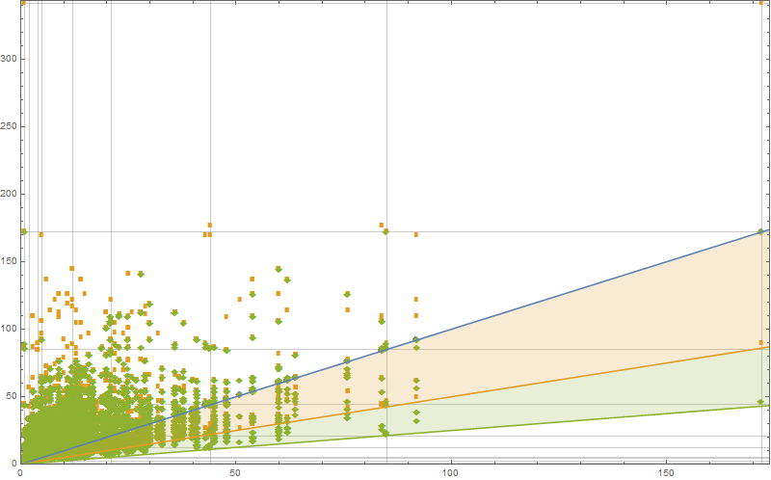
On this graph you can see the colofour transitions. Blue dots are due to rule1, orange dots due to rule 2, green dots due to rule 3. Since Rule 3 is drawn on top op rule 2 etc you get the false impression that all transitions are rule 3. The gridlines are on the successive Jacobstal numbers. In the upper right corner you can see a dot which seems to confirm the conjecture.

Update 20151022
Due to the experiment in 5.1 I had all the “pure” graphs that have a rule2 transformation that drops the colofour.
Here is a subset of these with vertexcount 10.
Inside these there are 3 graphs that will have a “maximal colofour drop” when rule2 is applied to them.
The last one, however is the “interesting”. This graph drops from 1056 to 600.
Now, if you divide 1056 by 24 (=4!) then you get 44. 44 appears in the Jakobsthal series. 1056 is also the “highest” colofour value among these pure graphs.

µJakobsthal graphs
With that in mind, I started to look what is so special about this last graph. It appears that the structure is very predictable. In fact, this “same” structure also appears with other vertex counts. That made me create a little (suboptimal) Mathematica snippet to generate them.
JacobsThalGraph[n_]:=With[{max=4+n},
Graph[
DeleteDuplicates[
Join[{1<->2,2<->3,1<->3,1<->4,2<->4,1<->5,max<->2,max<->3},
Flatten[Table[{i<->i-1,i<->3,i<->4},{i,5,max}]
]
]
]
]]

Here is the graph with 14 vertices
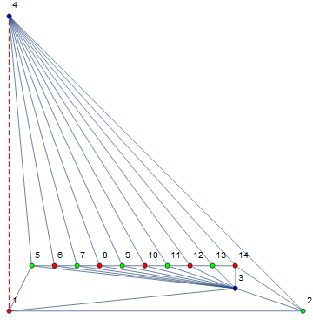
If we apply rule 2 around edge 1<->4 then we have a maximal drop. The following table shows the relation between the number of vertices of such a Jacobsthal graph and its colofour
Vertex count | Colofour
5 | 1
6 | 4
7 | 5
8 | 12
9 | 21
10 | 44
11 | 85
12 | 172
13 | 341
14 | 684
15 | 1365
16 | 2732
17 | 5461
18 | 10924
19 | 21845
20 | 43692
21 | 87381
22 | 174764
23 | 349525
24 | 699052
25 | 1398101
26 | 2796204
27 | 5592405
28 | 11184812
29 | 22369621
30 | 44739244
31 | 89478485
32 | 178956972
33 | 357913941
34 | 715827884

Jakobsthal graphs wheels
What more is there to say about these Jacobsthal graphs ? Well, if you don’t draw them as planar graphs but let Mathematica draw them, then you get the following nice pictures :
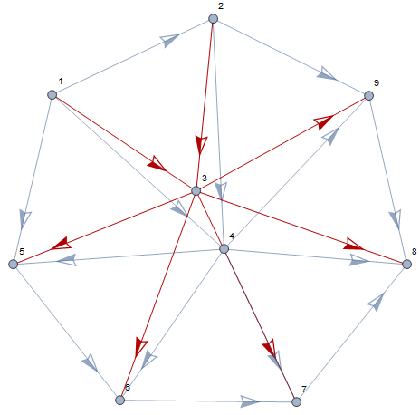
This looks like a double “wheel graph” with an “axe” consisting of vertices 3 and 4 (There is no edge between 3 and 4). I have added arrows to show all edges (especially between 3 and 7 and 4 and 7). The direction of the arrows is random. Since wheel graphs already exist in graph theory, we could call the bycycle wheel graphs.

The fish
There is another nice picture for Jacobsthal graphs. It has to do with the roots of their chromatic polynomials. In the following picture we have plotted these roots (blue) along with the roots of the chromatic polynomial of the graph after the colofour dropping rule 2 transition (orange). The result is nice but doesn’t bring me much insight:
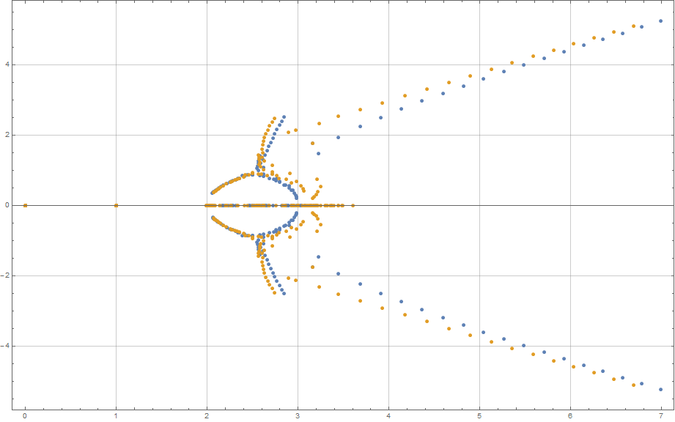
On the graph you see the complex roots of the jacobsthal graphs in blue and the reduced ones in orange. The graph looks like a fish swimming to the origin…

Observation about transitions at colofive
While some of the rule transitions cause a drop in colofour it appears to be that colofive (same as colofour but with five colors to choose from) never drops. Not even for graphs at which colofour drops.
- There is no drop in colofive for rule transitions from a graph with n vertices to a graph with n+1 vertices.
Here are two graphs to give evidence :
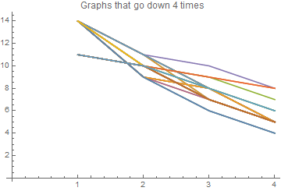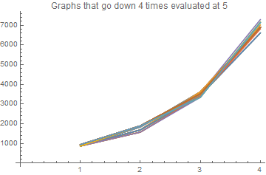
The left graph show some chains for which the colofour drops 4 times in a row (the x-axis is jst the number of drops in a row the y-axis show the colofour). The right graph shows these same chains but instead of the colofour we plot the colofive.

Observations that border numerology
There are some other observations that are so weak that I barely dare to voice them. However here it is.
It appears that the linear law for the minimum colofour also applies to five and six colors. Of course for five and six colors the “y” is always bigger than “x” (since there are no drops). However both of them seem to follow some kind of (seemingly linear) law. Of course 12 nodes are not enough to be sure about this.
For that amount of data the difference between a linear and a logarithmic or other law is too weak.
But here are the “plots for these transitions”

Colofive
The colofive is the number of ways to colour a givengraph with 5 colors. This number is divided by 60.

Rule1
If we draw the transitions for rule1, we can see that they now all lie on y=2x. This is very expected since a rule1 transition adds a vertex that can be coloured in 5-3 ways. Whatever the colofive of the original graphs, the colofive of the target graph will always be twice as much.
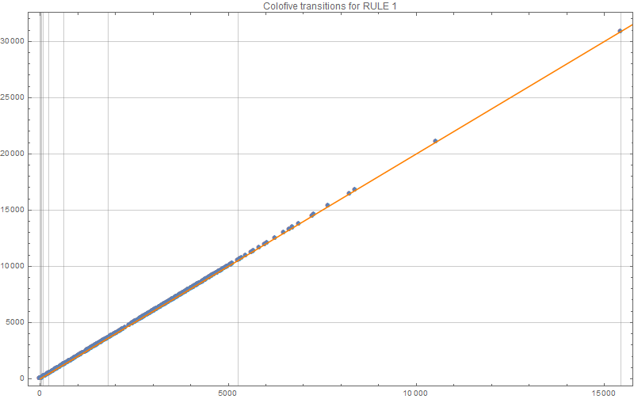

Rule 2
Of course, we can do the same for rule2 colofive transitions :
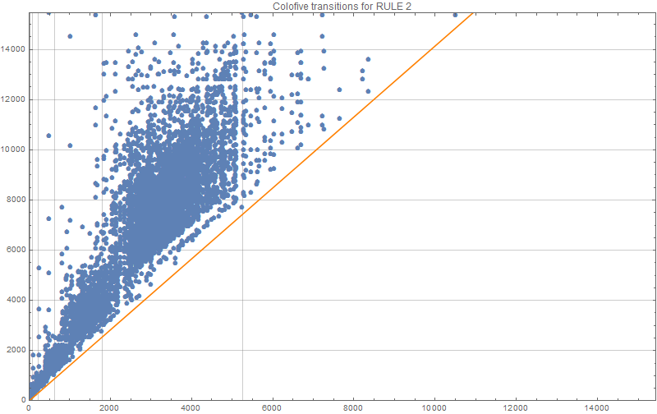
It seems that the forbidden line is at y= Sqrt(2)x, which is quite unexpected. Sqrt(2) could just as easily be some fraction in the neighbourhoud of 1.4. I just found it too suspiciously close to be a coincidence.

Rule 3
For rule3, we get the following graph:
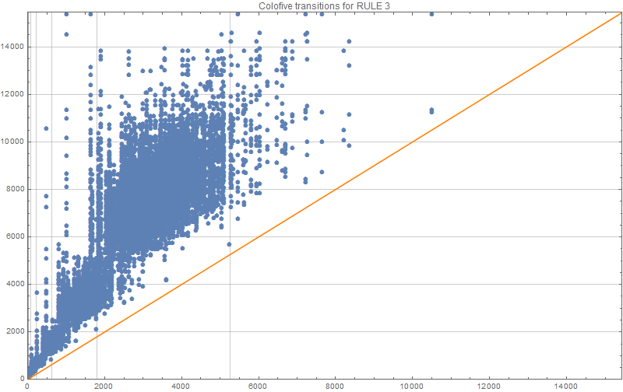
The forbidden line that I drew is a y=x. But that doesn’t seem to be 100% correct.

More Jacobsthal graphs

Jacobsthal graphs are colour champions.
When calculating the maximum colofour and colofive of maximal planar graphs with n vertices, I noticed that this maximum is attained only for certain graphs. It turns out that these are the bicycle wheel graphs we encountered before.
If what is true for 4 and 5 colours, then we can easily calculate these numbers. Before we proceed, there is one “normalization” that I would like to explain. We have already explained thatto get a colofour we divide the number of possibilities by 24. For colofive we divide by 60. Why ? Empirically we have seen that there is a GCD in these numbers. For 4 colors, the GCD is 24, for five it is 60, the following table lists te nex GCDs:
24, 60, 120, 210, 336, 504, 720, 990, 1320, 1716, 2184, 2730, 3360, 4080, 4896, 5814, 6840.
This series is known as http://oeis.org/A007531
This means that for colosix we divide by 120 etc…
Assuming the Jakobsthal graphs keep their champion status for higher numbers of colours, we get the following table.

 | 4 nodes | 5 nodes | 6 nodes | … |  |  |  |  |  |  |  |  | http://oeis.org/
Colofour | 1 | 4 | 5 | 12 | 21 | 44 | 85 | 172 | 341 | 684 | 1365 | 2732 | A155944
Colofive | 4 | 13 | 30 | 83 | 224 | 633 | 1810 | 5263 | 15444 | 45653 | 135590 | 404043
Colosix | 9 | 34 | 111 | 388 | 1365 | 4918 | 18027 | 67192 | 254001 | 971722 | 3754023 | 14617516
Coloseven | 16 | 73 | 308 | 1341 | 5880 | 26129 | 117532 | 535237 | 2466464 | 11493465 | 54111876 | 257137613
… | 25 | 136 | 705 | 3716 | 19685 | 105096 | 565465 | 3067276 | 16776045 | 92518256 | 514419425 | 2883066036
 | 36 | 229 | 1410 | 8767 | 54696 | 342889 | 2160270 | 13682227 | 87137556 | 558134749 | 3595974330 | 23306006887
 | 49 | 358 | 2555 | 18348 | 132069 | 953618 | 6908335 | 50222488 | 366470489 | 2684598078 | 19746623715 | 145861863428
 | 64 | 529 | 4296 | 35033 | 286160 | 2342433 | 19217752 | 158046697 | 1303115616 | 10773603377 | 89326932968 | 742858417401
 | 81 | 748 | 6813 | 62236 | 569205 | 5213764 | 47832957 | 439587532 | 4047196869 | 37333862740 | 345095673741 | 3196770154588
 | A000290 | A135859

If we log-plot them we get this :
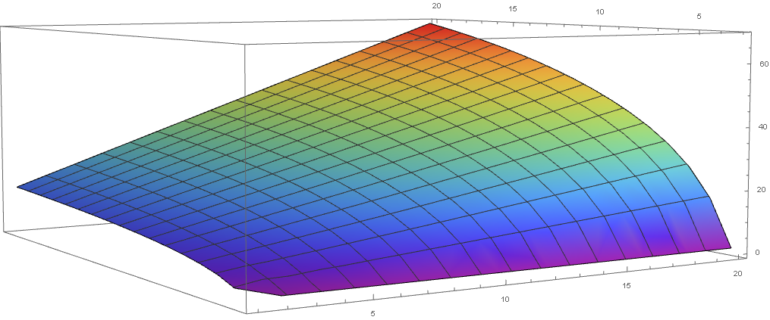
The only purpose of this plot image is that these numbers seem to be predictable. I have not yet spent time on finding a closed form for them.

Implementation
The calculation of a MPG is a hard problem. I first coded it in a very naïve way just to see if everything worked. Fortunately the number of graphs that we should find are documented on the internet. It is OEIS series A000109 : “1 1 1 2 5 14 50 233 1249 7595 49566 339722 2406841 17490241 129664753 977526957 7475907149 57896349553 453382272049 3585853662949”.
I first missed rule 3. This means that for 12 nodes I found 49565 different graphs. In other words I missed one graph : the icosahedron. If instead I would have read the article “generation of triangulations of the sphere” from 1965 ! then I would have found it at page 3.
I took my program about a day to generate 49566 graphs with 12 nodes. Plantri does the same in less than a second. In fact they have made their effort available on the internet : https://cs.anu.edu.au/people/Brendan.McKay/plantri .
I tried to edit plantri and adapt it to my needs. However this program is optimized to prevent a rule transition if it is known that it will not produce a new MPG. So while I succeeded in “recording” the transitions that plantri did it turned out that I missed the bulk of them (which of course is the whole idea behind that program).
In a way this was a relief because it meant that I had found why my program was so slow. It was not inherently slow. I just did many more calculations because I needed these extra calculations.
The bottleneck of the program is the polymorphism check. For a generation of graphs with 13 nodes this got called 160.520.426 times (we only do it for graphs with the same vertexcount signature) !, Rule1 produced a graph 169905 times, Rule 2: 241131 times and finally rule Rule 3 : 801342 times.
Nevertheless I rewrote my program. There are plenty of ways to represent a graph. However I chose to represent graphs as faces. Each Face has a list of its neighbor faces. The program is written in c# and might be made about 2 orders of magnitude faster by coding it in c++. I have not done that because c+ is 20 years behind me now. But I am still considering it.
With this representation rule1 becomes this :
foreach (var f in Faces)
{
var clone = Clone();

var clonedFace = clone.GetFaceById(f.FaceId);
var newVertex = clone.NextFreeVertexId();
var id = clone.NextFreeFaceId();

// create 3 new faces and replace old with new in neighbours of graph
var ne = CreateRule1SubFace(clonedFace clonedFace.Vertex1 clonedFace.Vertex2 newVertex ref id);
var nw = CreateRule1SubFace(clonedFace clonedFace.Vertex1 clonedFace.Vertex3 newVertex ref id);
var south = CreateRule1SubFace(clonedFace clonedFace.Vertex2 clonedFace.Vertex3 newVertex ref id);

// add 3 new faces
clone.AddFace(ne);
clone.AddFace(nw);
clone.AddFace(south);

// make them neighbours of each other
ne.AddNeighbour(nw);
ne.AddNeighbour(south);

nw.AddNeighbour(ne);
nw.AddNeighbour(south);

south.AddNeighbour(ne);
south.AddNeighbour(nw);

// remove old face
clone.RemoveFace(clonedFace);
yield return clone;
}
private Face CreateRule1SubFace(Face oldFace
int oldVertex1 int oldVertex2 int newVertex ref int id)
{
var newFace = new Face(oldVertex1 oldVertex2 newVertex) {FaceId = id};
id++;
foreach (var neighbour in oldFace.Neighbours)
{
if (neighbour.ContainsEdge(oldVertex1 oldVertex2))
{
neighbour.ReplaceNeighbour(oldFace newFace);
break;
}
}
return newFace;
}

Rule 2 is also quite readable :
var alreadyDone = new SortedSet<Edge>();

foreach (var leftFace in Faces)
{
foreach (var rightFace in leftFace.Neighbours)
{
var common = leftFace.CommonEdge(rightFace);

// avoid duplicate work this can happen since we attack each Face which means
// we visit each edge twice.
if (alreadyDone.Contains(common)) continue;
alreadyDone.Add(common);

int top = common.Vertex1 bottom = common.Vertex2;

// start new instance
var clone = Clone();

var nextFaceId = clone.NextFreeFaceId();
var newVertex = clone.NextFreeVertexId();
var leftFaceCloned = clone.GetFaceById(leftFace.FaceId);
var rightFaceCloned = clone.GetFaceById(rightFace.FaceId);

leftFaceCloned.RemoveNeighbour(rightFaceCloned);
rightFaceCloned.RemoveNeighbour(leftFaceCloned);

var leftVertex = leftFaceCloned.RemainingVertex(common);
var rightVertex = rightFaceCloned.RemainingVertex(common);

// create the faces
var leftTop = new Face(newVertex top leftVertex){FaceId = nextFaceId++};
var leftBottom = new Face(newVertex bottom leftVertex) ){FaceId = nextFaceId++};
var rightTop = new Face(newVertex top rightVertex) ){FaceId = nextFaceId++};
var rightBottom = new Face(newVertex bottom rightVertex) ){FaceId = nextFaceId++};

// add faces
clone.AddFace(leftTop);
clone.AddFace(leftBottom);
clone.AddFace(rightTop);
clone.AddFace(rightBottom);

// fix the neighbours among the new
leftTop.AddNeighbour(leftBottom);
leftTop.AddNeighbour(rightTop);

leftBottom.AddNeighbour(leftTop);
leftBottom.AddNeighbour(rightBottom);

rightTop.AddNeighbour(rightBottom);
rightTop.AddNeighbour(leftTop);

rightBottom.AddNeighbour(rightTop);
rightBottom.AddNeighbour(leftBottom);

// fix the old neighbours left
foreach (var neigh in leftFaceCloned.Neighbours)
{
if (neigh.ContainsEdge(top leftVertex))
{
neigh.ReplaceNeighbour(leftFaceCloned leftTop);
continue;
}
if (neigh.ContainsEdge(bottom leftVertex))
{
neigh.ReplaceNeighbour(leftFaceCloned leftBottom);
continue;
}

throw new AccessViolationException();
}

// fix the old neighbours right
foreach (var neigh in rightFaceCloned.Neighbours)
{
if (neigh.ContainsEdge(top rightVertex))
{
neigh.ReplaceNeighbour(rightFaceCloned rightTop);
continue;
}
if (neigh.ContainsEdge(bottom rightVertex))
{
neigh.ReplaceNeighbour(rightFaceCloned rightBottom);
continue;
}
throw new AccessViolationException();
}

clone.RemoveFace(rightFaceCloned);
clone.RemoveFace(leftFaceCloned);

yield return clone;
}
}

And finally here is rule 3 :
foreach (var leftFace in Faces)
{
foreach (var middleFace in leftFace.Neighbours)
{
var commonLeft = leftFace.CommonEdge(middleFace);

foreach (var rightFace in middleFace.Neighbours)
{
if (rightFace.FaceId == leftFace.FaceId) continue;
var commonRight = middleFace.CommonEdge(rightFace);

var topVertex = commonRight.SharedVertexWith(commonLeft);
if (topVertex<0) continue;

var vertex1 = topVertex;
var vertex3 = commonRight.OtherVertex(vertex1);
var vertex4 = commonLeft.OtherVertex(vertex1);
var vertex2 = rightFace.RemainingVertex(new Edge(vertex1 vertex3));
var vertex5 = leftFace.RemainingVertex(new Edge(vertex1 vertex4));

var clone = Clone();

var nextFaceId = clone.NextFreeFaceId();
var newVertex = clone.NextFreeVertexId();

var leftFaceCloned = clone.GetFaceById(leftFace.FaceId);
var middleFaceCloned = clone.GetFaceById(middleFace.FaceId);
var rightFaceCloned = clone.GetFaceById(rightFace.FaceId);

leftFaceCloned.RemoveNeighbour(middleFaceCloned);
rightFaceCloned.RemoveNeighbour(middleFaceCloned);
middleFaceCloned.RemoveNeighbour(leftFaceCloned);
middleFaceCloned.RemoveNeighbour(rightFaceCloned);

var face1 = new Face(newVertex vertex1 vertex2) { FaceId = nextFaceId++ };
var face2 = new Face(newVertex vertex2 vertex3) { FaceId = nextFaceId++ };
var face3 = new Face(newVertex vertex3 vertex4) { FaceId = nextFaceId++ };
var face4 = new Face(newVertex vertex4 vertex5) { FaceId = nextFaceId++ };
var face5 = new Face(newVertex vertex5 vertex1) { FaceId = nextFaceId };

// add faces
clone.AddFace(face1);
clone.AddFace(face2);
clone.AddFace(face3);
clone.AddFace(face4);
clone.AddFace(face5);

// add the neighborhood among the new faces
face1.AddNeighbour(face2);
face2.AddNeighbour(face3);
face3.AddNeighbour(face4);
face4.AddNeighbour(face5);
face5.AddNeighbour(face1);

foreach (var neigh in leftFaceCloned.Neighbours)
{
if (neigh.ContainsEdge(vertex1 vertex5))
{
neigh.ReplaceNeighbour(leftFaceCloned face5);
continue;
}
if (neigh.ContainsEdge(vertex4 vertex5))
{
neigh.ReplaceNeighbour(leftFaceCloned face4);
continue;
}
throw new InvalidOperationException();
}

foreach (var neigh in middleFaceCloned.Neighbours)
{
if (neigh.ContainsEdge(vertex3 vertex4))
{
neigh.ReplaceNeighbour(middleFaceCloned face3);
continue;
}

throw new InvalidOperationException();
}

foreach (var neigh in rightFaceCloned.Neighbours)
{
if (neigh.ContainsEdge(vertex2 vertex3))
{
neigh.ReplaceNeighbour(rightFaceCloned face2);
continue;
}
if (neigh.ContainsEdge(vertex1 vertex2))
{
neigh.ReplaceNeighbour(rightFaceCloned face1);
continue;
}
throw new InvalidOperationException();
}

clone.RemoveFace(rightFaceCloned);
clone.RemoveFace(middleFaceCloned);
clone.RemoveFace(leftFaceCloned);
clone.CheckSanity();
clone.Title = Title + " <3>" + commonLeft + "*" + commonRight;

yield return clone;
}

Optimization : partition key
The original program was rather slow. I pointed a profiler at it and measured where it spent its time. Not to my surprise I found out that the bulk of the time was spent in testing for graph isomorphism.
To know what I improved I must first explain how it worked.
I had already noticed that the graph isomorphism test was slow. The main point then was to avoid having to run it. So I calculted a “graph signature”. This is a string based upon some graph invariant. Two graphs which are not isomorphic would get a different string. However, it was possible that graphs with the same string were not isomorphic either. So the “graph signature” actually partitions the graphs.
The advantage of this approach is that we only have to test the elements in a given partition set for graph isomophism with the newly discovered set. The more graphs in the partition set, the fewer elements in each of them and the faster the algorithm.
My original partition key was based on the degrees of the vertices : take the degree of each vertex; sort the list in whatever order and concatenate the degrees, separated by a separator (a dash).
This key works very well for graphs with small vertex counts. However, as the number of vertices goes up, the size of the buckets went from 1-2 to 800+. Testing for graph isomophism with the 800 graphs in such a bucket is essentially a linear process. I was able to perform this test in parallel, but that only makes it k times faster (where k is the number of procesors in your machine).
I had already realized that it would be very interesting to have a so-called canonical labeling algorithm at my disposal. Such labelings give a unique signature to each graph. Isomorphic graphs get the same label. Unfortunately, I didn’t have this. Giving standard search technology such as a hash table, such a labeling would dramtically improve the performance. Although it could be slow, it had to be computed for each graph only once. After that everything could be handled with strings.
Then I realized that I could improve my signature by adding the degrees of the neighbours to it. So instead of a signature that look like this : 3-3-4-4-4-4-5-6-6-7-8", I had a partition key that looks like this 3[6*5*4]-3[8*6*4]-4[7*6*5*3]-4[8*6*4*3]-4[8*7*6*4]-4[8*7*6*6]-5[8*7*6*4*3]-6[8*7*4*4*4*3]-6[8*7*5*4*4*3]-7[8*6*6*5*4*4*4]-8[7*6*6*5*4*4*4*3]"
This way I could distinguish more graphs. In noticed that the more complicated signature didn’t make any difference for the smaller graphs. However, the speedup for graphs with 11 or more nodes was dramatical.
What was even nicer is that I realized that this signature could be even further improved. Instead of going “1-deep” to the direct neighbours, we could also go 2-deep or even k-deep. The size of the signature would grow exponentially with each new depth but it would also substantially reduced the size of the partition buckets. Clearly, there is some balance to be found here and I have to come up with a heuristic that links the depth of the partition key to the number of vertices in the graph.

References :
- Fast generation of planar graphs by Gunnar Brinkmann and Brendan D. McKay
- The boost Graph library
- The chromatic polynomials and chromaticiy of graphs . Gong Koh & Teo.
- The four color theorem Saaty and Kainen.
- Computing chromatic polynomials for special families of graphs Loering Beatrice
- Handbook of graph drawing an visualization Tamassia
- Graph theory and its applications Jonathan L. Gross Jay Yellen
- Graphs Colourings and the four-colout theorem Robert a. Wilson
- Graph algorithms Shimon Even and guy Even.
- Counting on frameworks Jack E. Graver.
- Algorithmic graph theory and perfect graphs Martin Charles Columbic.
- The knot book Colin C. Adams
- The theory of graphs Claude berge
- Graph Theory As I Have Known It Tutte
- Efficient Algorithms for Listing Combinatorial Structures Leslie Golberg
- Pearls in Graph Theory: A Comprehensive Introduction Nora Hartsfield
- Modern Graph Theory Bollobas Bela
- Algebraic Graph Theory Godsil Chris
- Discrete And Combinatorial Mathematics: An Applied Introduction R. Grimaldi
- Planar Graph Isomorphism is in Log-Space Samir Datta Nutan Limaye Prajakta Nimbhorkar Thomas Thierauf Fabian Wagner.
- Subgraph Isomorphism in Planar Graphs and Related Problems David Eppstein
- Is the four-color conjecture almost false Sami Beraha Joseph Kahane.
- How to draw a graph Tutte
- A simple linear time algorithm for embedding maximal planar graphs Hermann Stamm-Wilbrandt.
- Generation of triangulations of the sphere Robert Bowen and Stephen Fisk.

I stole these images without permission from the paper by Gunnar Brinkmann and Brendan D. McKay. The special marks at the vertices are used there to avoid rules that produce isomorphic graphs. We ignore them here since we want to be sure not to miss any rule production.
In fact there is a paper that links Jacobstal numbers to generalized Petersen graphs (http://eurocomb2015.b.uib.no/files/2015/08/endm1943.pdf) so the link might not be as far-fetched.
The recurrence of the Jacobsthal numbers J(n)=J(n-1)+2J(n-2) could maybe provide a hint.

